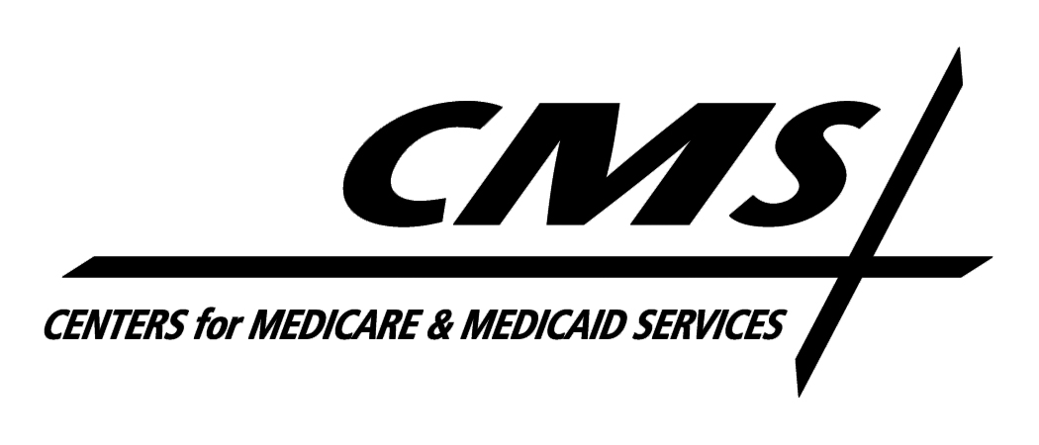Department of Health & Human Services
Centers for Medicare & Medicaid Services
7500 Security Boulevard, Mail Stop S3-13-15
Baltimore, Maryland 21244-1850

Center for Medicaid and State Operations

November 16, 2010

TO: Drug Rebate Technical Contacts

FROM: Medicaid Drug Rebate Program

SUBJECT: Deleted Products--Immediate Action Required

CMS has determined that the following device products do not meet the definition of a covered outpatient drug as set forth in Section 1927(k)(2) of the Social Security Act (the Act). The FDA has informed us that labeler 42546 received approval to market these products as devices under section 510(k) of the Federal Food, Drug and Cosmetic Act. As a result, they are no longer eligible for inclusion in the Medicaid Drug Rebate Program. The device products that are no longer rebate eligible are as follows:

NDC Product Name

42546- 0130 Prutect Cream
42546-0412 Pruclair Cream

Consequently, these NDCs should be deleted from your state Medicaid Drug Rebate system as of the date of this notice. The labeler of these products is responsible for paying rebates on these NDCs if they were dispensed on the date of this notice or earlier. In addition, states should be aware that the fourth quarter 2010 tape to states will be the last quarterly tape that will include these NDCs in order to facilitate rebate billing for any utilization that occurred in good faith on or prior to the date of this notice. However, states are reminded that no Federal Financial Participation will be available for these NDCs after the date of this notice for purposes of the Medicaid Drug Rebate Program.

