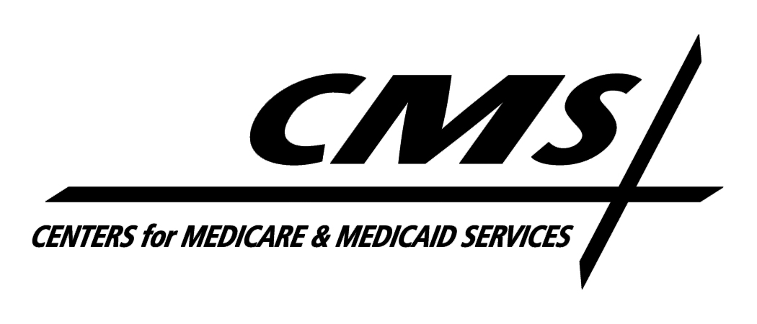Department of Health & Human Services
Centers for Medicare & Medicaid Services
7500 Security Boulevard, Mail Stop S2-13-15
Baltimore, Maryland 21244-1850

Center for Medicaid , CHIP, and Survey & Certification

June 2, 2011

TO: Drug Rebate Technical Contacts

FROM: Medicaid Drug Rebate Program

SUBJECT: Deleted Products--Immediate Action Required

The Food and Drug Administration (FDA) has informed us that the following extended release Hyoscyamine products are subject to Federal regulations at 21 CFR 310.502(a)(14), which state that timed-release dosage forms are new drugs within the meaning of section 201(p) of the Federal Food, Drug, and Cosmetic Act, and that such drugs require FDA approval before marketing. According to the FDA, these products do not have approved applications; therefore, CMS has determined that the NDCs do not meet the definition of a covered outpatient drug as defined in Section 1927(k) of the Social Security Act and are subsequently no longer eligible for inclusion in the rebate program. Consequently, the following extended release Hyoscyamine NDCs should be deleted from your state Medicaid Drug Rebate system as of the date of this notice. The labelers of these products are responsible for paying rebates on any of the NDCs if they were dispensed prior to the date of this notice. In addition, States should be aware that the second quarter 2011 drug rebate file will be the last quarterly file that will include the NDCs in order to facilitate rebate billing for any utilization that occurred in good faith prior to the date of this notice. However, States are reminded that these drugs are no longer eligible for FFP as covered outpatient drugs or qualify for coverage under the Medicaid Drug Rebate Program. As a reminder, while these products are not eligible for Medicaid coverage or FFP under the Medicaid Drug Rebate Program, they may be eligible for Medicaid coverage or FFP as part of home health services, EPSDT services as defined in section 1905(r)(5) of the Social Security Act, or elsewhere to the extent that such coverage is consistent with the approved state plan.

NDC Product Name

00574-0251 HYOSCYAMINE SULFATE EXTENDED-RELEASE TABLETS
13925-0108 HYOSCYAMINE .375 EXTENDED RELEASE TABLETS
24486-0602 HYOMAX SR
24486-0604 HYOMAX DT
43199-0014 HYOSCYAMINE SULFATE EXTENDED RELEASE TABLETS 0.375 MG
52152-0156 HYOSCYAMINE SR 0.375MG(100) TAB
58177-0017 L-HYOSCYAMINE SULFATE
58177-0237 HYOSCYAMINE .375MG
64125-0110 HYOSCYAMINE SULFATE 0.375 MG ER TABLETS
64543-0112 SYMAX SR
64543-0118 SYMAX DUOTAB
68032-0251 Hyoscyamine Sulfate 0.125 mg IR, Hyoscyamine Sulfate 0.25 mg SR
68220-0115 LEVBID

