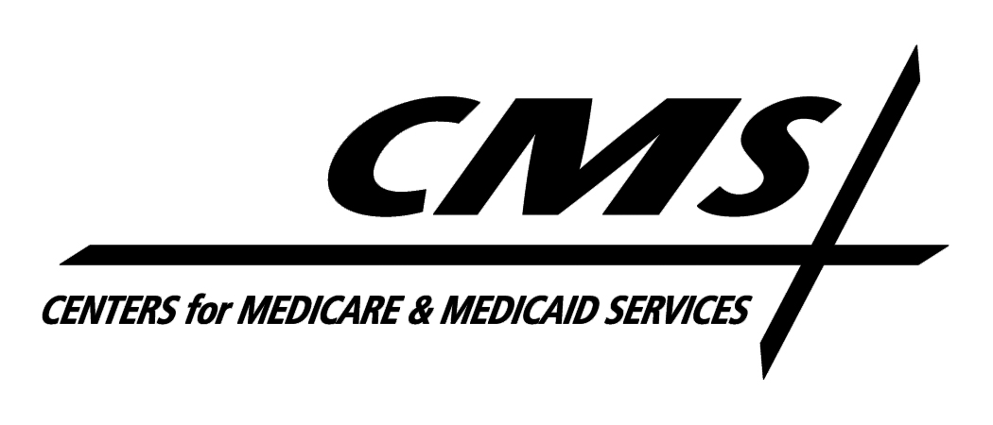Department of Health & Human Services
Centers for Medicare & Medicaid Services
7500 Security Boulevard, Mail Stop S3-13-15
Baltimore, Maryland 21244-1850

Center for Medicaid and State Operations

April 2, 2009

TO: Drug Rebate Technical Contacts

FROM: Medicaid Drug Rebate Program

SUBJECT: Deleted Products--Immediate Action Required

CMS has determined that the following unapproved drug products containing sodium hyaluronate do not appear to meet the definition of a covered outpatient drug as set forth in Section 1927(k)(2) of the Social Security Act (the Act). As a result, they are no longer eligible for inclusion in the Medicaid Drug Rebate Program. The drug products that are no longer rebate eligible are as follows:

NDC Product Name

50383-0293 Sodium Hyaluronate Lotion 0.1%
60258-0025 Sodium Hyaluronate 0.1%
63717-0034 Hylira .2% Gel
63717-0036 Hylira
68032-0238 Sodium Hyaluronate 0.1% Lotion
68032-0348 Sodium Hyaluronate 0.2% Gel

Consequently, these NDCs should be deleted from your state Medicaid Drug Rebate system as of the date of this notice. The labelers of these products are responsible for paying rebates on these NDCs if they were dispensed on or prior to the date of this notice. In addition, states should be aware that the second quarter 2009 tape to states will be the last quarterly tape that will include these NDCs in order to facilitate rebate billing for any utilization that occurred in good faith on or prior to the date of this notice. However, states are reminded that no Federal Financial Participation will be available for these NDCs after the date of this notice for purposes of the Medicaid Drug Rebate Program.

