Department of Health & Human Services
Centers for Medicare & Medicaid Services
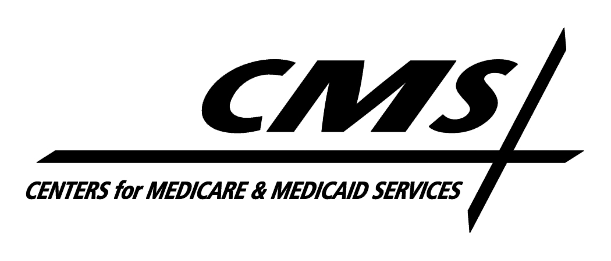7500 Security Boulevard, Mail Stop S3-13-15
Baltimore, Maryland 21244-1850

Center for Medicaid and State Operations

April 13, 2009

TO: Drug Rebate Technical Contacts

FROM: Medicaid Drug Rebate Program

SUBJECT: Deleted Products-Immediate Action Required

Labelers included the following dietary supplements on the CMS file. These NDCs do not meet the definition of a covered outpatient drug as defined in Section 1927(k) of the Social Security Act and are therefore no longer eligible for inclusion in the rebate program. Consequently, these NDCs should be deleted from your state Medicaid Drug Rebate system as of the date of this notice. The labelers of these products are responsible for paying rebates on any of these NDCs that were dispensed prior to the date of this notice. In addition, states should be aware that the first quarter 2009 tape to states will be the last quarterly tape that will include these NDCs in order to facilitate rebate billing for any utilization that occurred in good faith prior to the date of this notice. However, states are reminded that no Federal Financial Participation will be available for these drugs after the date of this notice.

NDC Product Name

00024 0391 DRISDOL DRISDOL

00091 4150 CALCIFEROL DROPS

