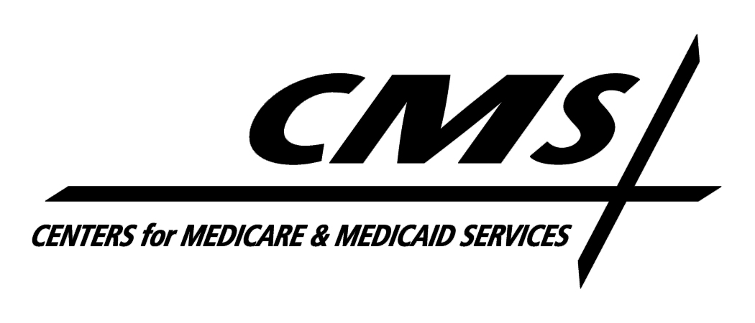Department of Health & Human Services
Centers for Medicare & Medicaid Services
7500 Security Boulevard, Mail Stop S3-13-15
Baltimore, Maryland 21244-1850

Center for Medicaid and State Operations

July 2, 2008

TO: Drug Rebate Technical Contacts

FROM: Medicaid Drug Rebate Program

SUBJECT: Deleted Product--Immediate Action Required

CMS has determined that the following NDC does not meet the definition of a covered outpatient drug as set forth in Section 1927(k)(2) of the Social Security Act (the Act). As a result, it is no longer eligible for inclusion in the Medicaid Drug Rebate Program. The drug product under labeler code 16881 that is no longer rebate eligible is as follows:

NDC Product Name

16881-0300 AURALGAN OTIC

Consequently, this NDC should be deleted from your state Medicaid Drug Rebate system as of the date of this notice. The labeler of this product is responsible for paying rebates on this NDC if it was dispensed prior to the date of this notice. In addition, states should be aware that the second quarter 2008 tape to states will be the last quarterly tape that will include this NDC in order to facilitate rebate billing for any utilization that occurred in good faith prior to the date of this notice. However, states are reminded that no Federal Financial Participation will be available for this NDC after the date of this notice.

